GroupSelect
0) Copy and paste the data from PoliticalCandidate.txt
1) Display the records in the candidate table such that first name, last name and dob appear as one single column with a column alias named (full information). Place a comma as a separator between each field. Also make sure that you upper case the first letter of both the first and last name. (Use the concat function or the || symbols)
e.g. John,James,01 Feb 90
SELECT INITCAP(fname) || ', ' || INITCAP(lname) || ', ' || dob AS "Full Information" FROM mendoza_candidate;

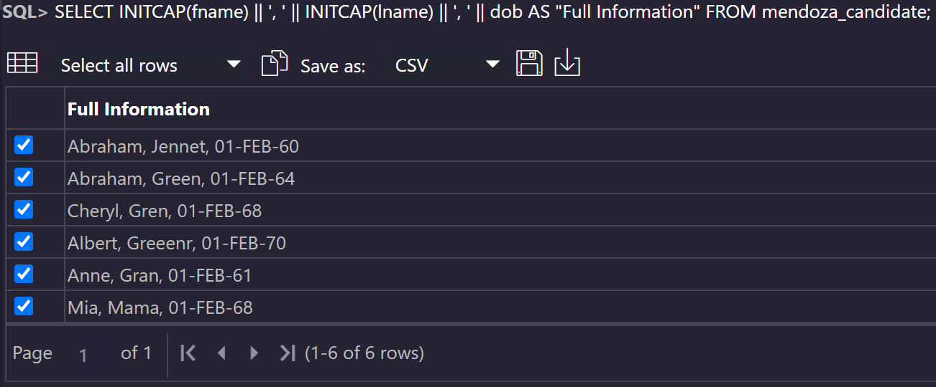
2) Display the name and age of each of the candidates. (You have to calculate the age using the various date functions based on date of birth)
SELECT INITCAP(fname), TRUNC(MONTHS_BETWEEN(SYSDATE,DOB)/12) FROM mendoza_candidate;

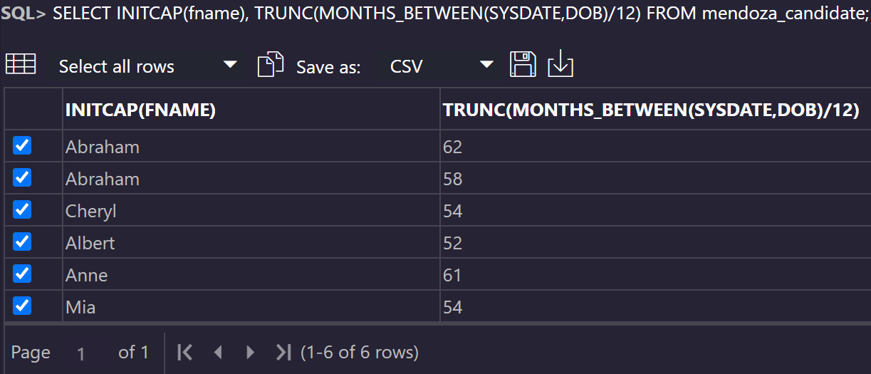

3) Display the last name of all the candidates. Make sure that no duplicate last names are displayed
SELECT UNIQUE INITCAP(lname) AS "Last Name" FROM mendoza_candidate;

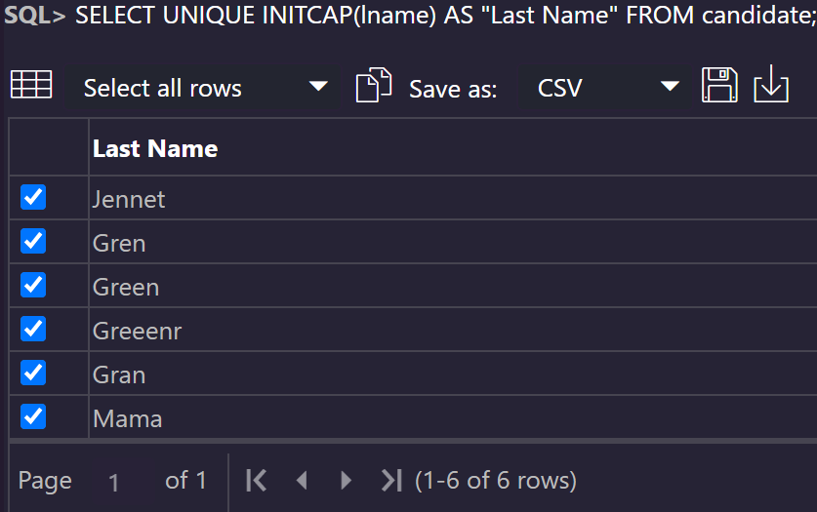

4) Display the first name of all the candidates who are greater than 40 years old
SELECT INITCAP(fname) AS "First Name" FROM mendoza_candidate WHERE TRUNC(MONTHS_BETWEEN(SYSDATE, DOB)/12) > 40;

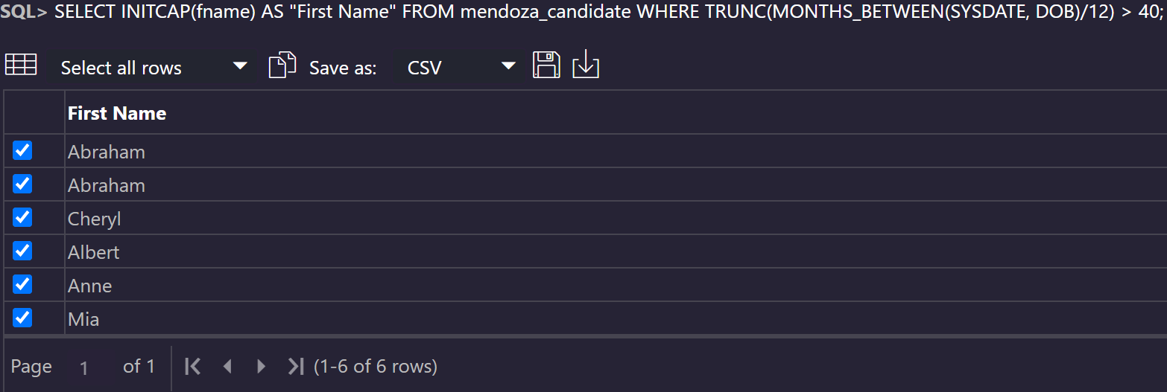

5) Display the first name of all the candidates whose salary is null, as well as salaries that are between 20,000 and 40,000
SELECT INITCAP(fname) AS "First Name", salary FROM mendoza_candidate WHERE salary BETWEEN 20000 AND 40000 OR salary IS NULL;

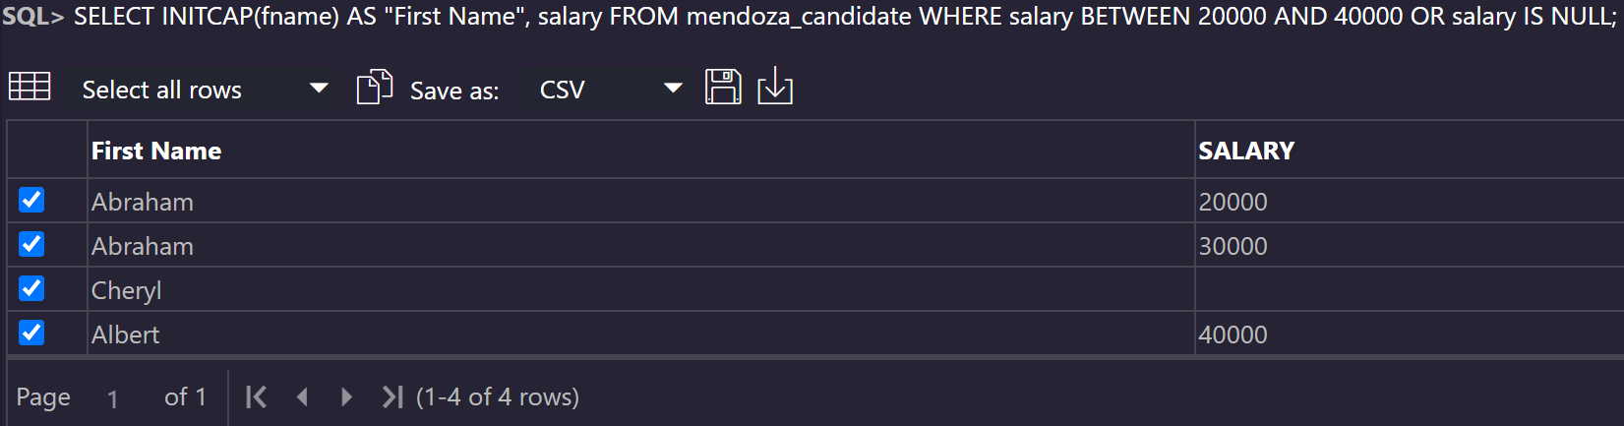

6) Display the first name of all the candidates that begin with the character ‘C’ regardless of case and are older than 40 years old
SELECT INITCAP(fname) AS "First Name" FROM mendoza_candidate WHERE fname LIKE 'c%' AND TRUNC (MONTHS_BETWEEN(SYSDATE, DOB)/12) > 40;

